**Lab 10-1: Local Feature Matching**

**2020 Spring**

**Multi-Media & Lab**

**Name/ID: 201533661 이승수**

**Dept: Software**

**[Result]**

Result of box image matching at class

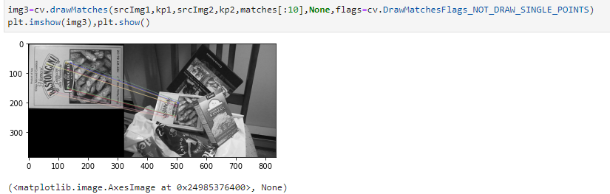

Do same with my own images.

|  |  |
| --- | --- |
| srcImg1 | srcImg2 |

Result of my own images

